TOWN OF
PETERBOROUGH
Administration
1 Grove Street
Peterborough, NH 03458
Office: (603) 924-8000 x.101
Fax: (603) 924-8001
Web: www.townofpeterborough.com

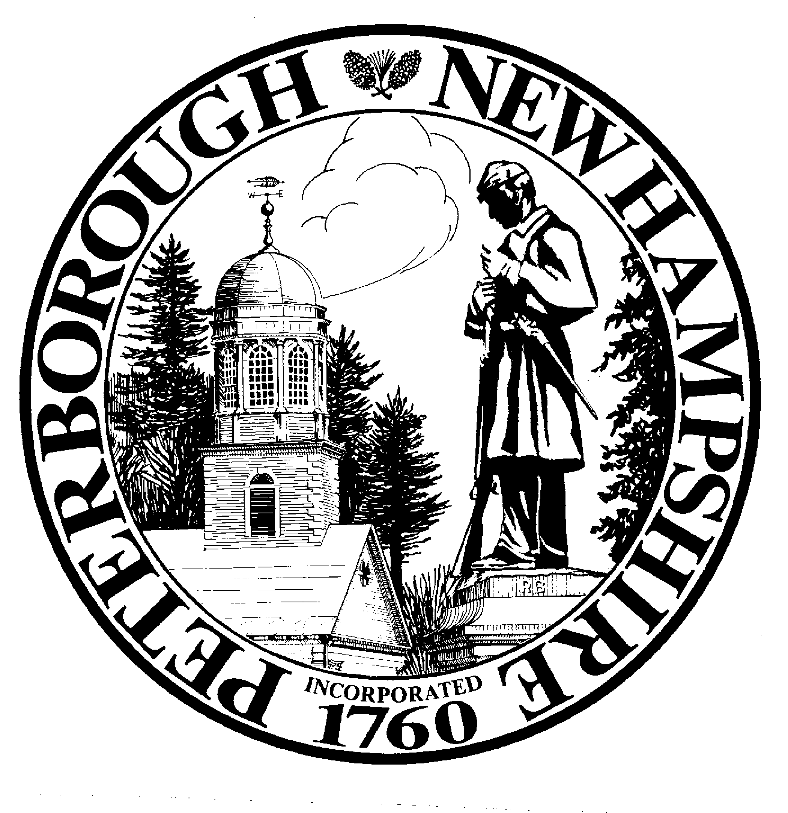

MEMO

To: Select Board
From: Nicole MacStay, Town Administrator
Date: October 24, 2022
RE: Sale of Town-Owned Property off of Greenfield Road – Parcel ID R012-035-000

Recently the property located at 730 Greenfield Road was sold. During that sale process the Town learned that the prior owner had extended the back yard and driveway onto town-owned property, and had built a shed on that property. The new property owners have approached the Town with an offer to purchase that town-owned property for $3,000.

The Town acquired this parcel through tax deeding in 2001. The parcel is approximately one acre, and is substantially wet. The one portion of the property that is upland is only accessible through 730 Greenfield Road. The property is located in the Rural District, which requires a minimum of three acres to be considered buildable. Sale of this property to the owners of 730 Greenfield Road will remedy the trespass and cure the existing encroachment into the side setback.

I have initiated the process required by RSA 41:14-a for the sale of town-owned property. Two public hearings have been scheduled for November 1 and November 15, and a meeting for a final vote will need to be held between November 22 and November 29. I have also reached out to the Planning Board, Conservation Commission and Heritage Commission to request that they review the proposed sale and provide their recommendations to you for your consideration.

